**Name : Lalit Jain**

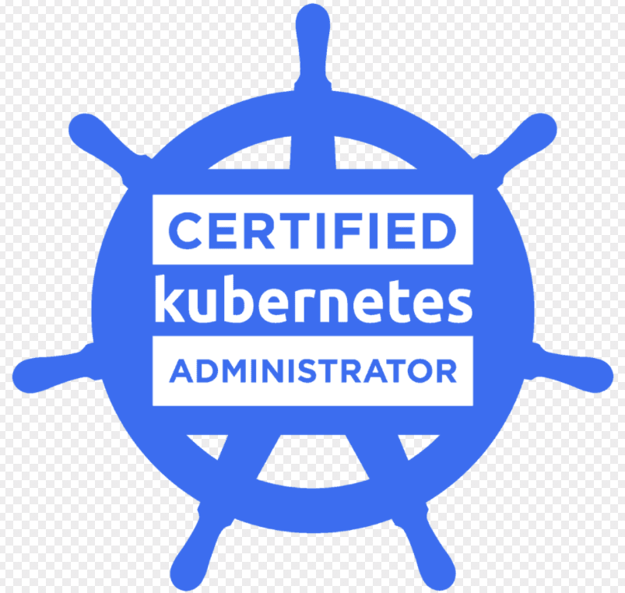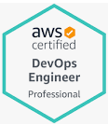

* **Certified Kubernetes Administrator(ID: LF-jq8selv4ro)**
* **AWS Certified Devops Engineer** ( ID: KD5M40TCFM11QE9H)
* **AWS Certified Solutions architect- Associate** (ID: AWS-ASA-20054)

7+ years of experience into DevOps with a demonstrated history of working in the information technology and services industry. I am exposed to architecture, engineering, integration, implementation, Migration and administration of various highly-available infrastructure, visualization platforms and cloud infrastructure.

* Skilled in Azure, AWS, GCP, K8S, AKS, EKS, Terraform, Helm, Ansible, Splunk, Prometheus, Grafana, Jenkins CI/CD Pipelines, Jenkins-X , Vagrant, Packer, Ansible Tower, Docker, Dynatrace, Splunk, Helm Charts, Infrastructure as Code, Zabbix, ELK, Grafana with Prometheus /Elasticsearch, Linux, Shell Scripting, Python, Subversion, Apache Webserver, Load Balancing, HA Proxy, Apache Tomcat.

**SKILLS:**

|  |  |
| --- | --- |
| Operating Systems | Linux (Redhat, Centos and Ubuntu), CoreOS and Windows server |
| CM Tools | Ansible |
| Micro services Orchestration Tools | Kubernetes(AKS and EKS), Helm, Docker Compose |
| Version Control | Subversion, GIT |
| Build Tools | Maven, Ant, Gradle |
| CI/CD Tools | Jenkins (Pipeline as code), Bamboo, GO CD |
| Cloud Computing | AWS, GCP, Azure |
| Private Cloud | VMWare, Hyper-V |
| IAAC Tools | Packer, Terraform |
| Scripting Languages | Unix shell scripting, YAML, Powershell, Python(Basics) |
| Web Servers | IIS, Apache Web Server, nginx |
| Application Servers | Apache Tomcat |
| Monitoring and Logging | Dynatrace and Splunk, ELK |
| Search Platform | Solr with Zookeeper and Elasticsearch |
| CDN | Akamai and AWS Cloudfront |
| Databases | MySQL, MSSQL, PostgreSQL |

**Professional Summary:**

* Around 7+ years of experience into DevOps with strong experience in Kubernetes, Helm, Azure/AWS, Ansible, Terraform
* Managing applications and the systems highly available with zero-downtime
* Having experience in windows server environment and handling of ASP.net applications
* Extensive and comprehensive experience with various Operating Systems such as.
* Linux distributions as Red Hat, Centos, Ubuntu, etc. Windows Server 2012, 2008 & 2003 Active Directory, Group Policies, DHCP, DNS, WDS, and other Roles and Feature Management.
* Monitoring tools like Prometheus, Grafana, ELK stack, Kibana etc.
* Backup automation using shell scripting.
* Implemented Docker and Kubernetes for container management and integrated with Jenkins CI/CD pipelines.
* Managing Linux operating Systems (RHEL, CentOS, Ubuntu) including user access management (ACL’s), Firewalls, LVM (Logical Volume Management), Performance Tuning, Cron jobs etc.
* Good experience in Docker with orchestration using Kubernetes(K8S).
* Experienced in setting up the end-to-end CI/CD for the containers with Jenkins Pipeline as Code and Kubernetes.
* Sound experience in managing Infrastructure as Code using Packer and Terraform for multiple cloud providers like AWS, Azure and GCP.

WORK EXPERIENCE:

Right Point India Pvt Ltd, Jaipur

Duration: Feb 2018 to till now

Designation: Senior Systems Engineer

Role and Responsibilities:

* Managing Azure and AKS clusters.
* Automating the end-to-end infrastructure provisioning with Terraform, configuration management with Ansible and application deployments using Helm and CI/CD with Jenkins pipeline as code
* Setting up and managing CI/CD tools:- Jenkins, Azure Devops , gitlab etc.
* Extensive and comprehensive experience with various Operating Systems such as.
* Linux distributions as Red Hat, Centos, Ubuntu, etc. Windows Server 2012, 2008 & 2003 Active Directory, Group Policies, DHCP, DNS, WDS, and other Roles and Feature Management.
* Monitoring tools like Prometheus, Grafana, ELK stack, Kibana etc.
* Backup automation using shell scripting.
* Implemented Docker and Kubernetes for container management and integrated with Jenkins CI/CD pipelines.
* Setting up the monitoring for the entire infrastructure (Private Cloud) using ELK/Grafana and Prometheus.
* Created Python scripts to manage few services based on the requirement on AWS.
* Working on Jenkins-X to setup staging environments for the developers to test their code before pushing the code to stable branches in GIT.
* Working on Helm charts to manage the Kubernetes applications.
* Created an end-to end CI/CD pipeline with Jenkins, Docker, Kubernetes (K8S).
* Writing and managing Infrastructure as a Code using Packer and Terraform to manage the entire infrastructure hosted in AWS.
* Creating the end-to-end Continuous Integration and Continuous Deployment CI/CD Pipelines in Jenkins with Pipeline as code.
* Administered the GIT and managed the access for users of the GIT repositories.
* Automating the complete SDLC from lower environments to till production.
* Implemented Kubernetes with Traefik for load-balancing and HTTP reverse proxy to deploy microservices with ease.
* Implemented ELK for managing the server/application logs and server metrics by creating multiple dashboards in Kibana.
* Implemented CI-as-a-Service with Docker and Jenkins.

**Tools & Languages:**

GIT, Jenkins, , Shell, YAML, Tomcat, IIS , Apache Webserver, Windows Server 2012, 2016, NGINX, RHEL7, CentOS, Ant, Artifactory, Docker, Kubernetes, Consul, ELK, Packer, Terraform

WORK EXPERIENCE:

Colnovation Technologies Pvt Ltd, Jaipur

Duration: June 2012 to Jan-2018

Designation: Senior Systems Engineer

**Environment***:* Subversion, WINSCP, SSH, Mysql, MSSQL, Active Directory, Repository, Linux (RHEL and CentOS), Windows 2003 server , Windows 2008